Instructions for Accessing Wireless on Campus
- #1. Join the appropriate network (Mac/PC below)
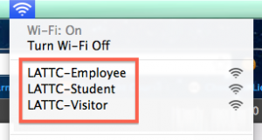 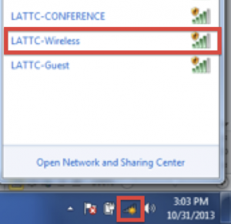
- #2. Open any web browser (such as Firefox for IE), and sign in with your Outlook ID and Password
  - Student Login
  - Username: your Student ID
  - Password: your PeopleSoft Password
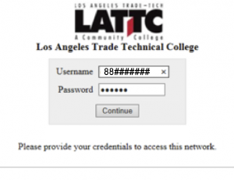
  - Employee Login
  - Username: your Outlook ID
  - Password: your Outlook Password
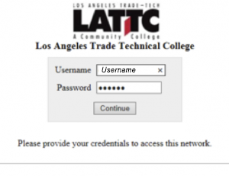
  - Visitor Login
  - Username: visitor
  - Password: latradetech
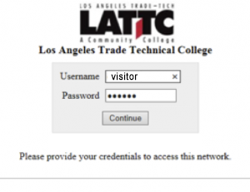
- #3. Accept Policy
